Conversion of analog signal to digital signal:

The output of most of the image sensors is an analog signal, and we can not apply digital processing on it because we can not store it. We can not store it because it requires infinite memory to store a signal that can have infinite values.

So we have to convert an analog signal into a digital signal.

To create an image which is digital, we need to covert continuous data into digital form. There are two steps in which it is done.

* Sampling
* Quantization

We will discuss sampling now, and quantization will be discussed later on but for now on we will discuss just a little about the difference between these two and the need of these two steps.

Basic idea:

The basic idea behind converting an analog signal to its digital signal is

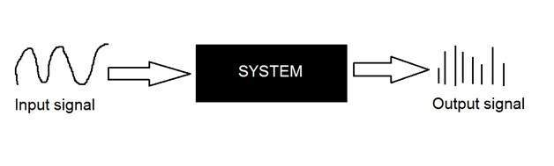

to convert both of its axis (x,y) into a digital format.

Since an image is continuous not just in its co-ordinates (x axis), but also in its amplitude (y axis), so the part that deals with the digitizing of co-ordinates is known as sampling. And the part that deals with digitizing the amplitude is known as quantization.

Sampling.

Sampling has already been introduced in our tutorial of introduction to signals and system. But we are going to discuss here more.

Here what we have discussed of the sampling.

The term sampling refers to take samples

We digitize x axis in sampling

It is done on independent variable

In case of equation y = sin(x), it is done on x variable

It is further divided into two parts , up sampling and down sampling

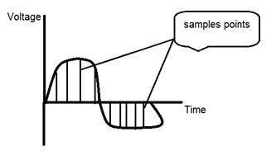

If you will look at the above figure, you will see that there are some random variations in the signal. These variations are due to noise. In sampling we reduce this noise by taking samples. It is obvious that more samples we take, the quality of the image would be more better, the noise would be more removed and same happens vice versa.

However, if you take sampling on the x axis, the signal is not converted to digital format, unless you take sampling of the y-axis too which is known as quantization. The more samples eventually means you are collecting more data, and in case of image, it means more pixels.

Relation ship with pixels

Since a pixel is a smallest element in an image. The total number of pixels in an image can be calculated as

Pixels = total no of rows * total no of columns.

Lets say we have total of 25 pixels, that means we have a square image of 5 X 5. Then as we have dicussed above in sampling, that more samples eventually result in more pixels. So it means that of our continuous signal, we have taken 25 samples on x axis. That refers to 25 pixels of this image.

This leads to another conclusion that since pixel is also the smallest division of a CCD array. So it means it has a relationship with CCD array too, which can be explained as this.

Relationship with CCD array

The number of sensors on a CCD array is directly equal to the number of pixels. And since we have concluded that the number of pixels is directly equal to the number of samples, that means that number sample is directly equal to the number of sensors on CCD array.

Oversampling.

In the beginning we have define that sampling is further categorize into two types. Which is up sampling and down sampling. Up sampling is also called as over sampling.

The oversampling has a very deep application in image processing which is known as Zooming.

Zooming

We will formally introduce zooming in the upcoming tutorial, but for now on, we will just briefly explain zooming.

Zooming refers to increase the quantity of pixels, so that when you zoom an image, you will see more detail.

The increase in the quantity of pixels is done through oversampling. The one way to zoom is, or to increase samples, is to zoom optically, through the motor movement of the lens and then capture the image. But we have to do it, once the image has been captured.

There is a difference between zooming and sampling

The concept is same, which is, to increase samples. But the key difference is that while sampling is done on the signals, zooming is done on the digital image.

In order to become suitable for digital processing, an image function f(x,y) must be digitized both spatially and in amplitude. Typically, a frame grabber or digitizer is used to sample and quantize the analogue video signal. Hence in order to create an image which is digital, we need to covert continuous data into digital form. There are two steps in which it is done:

* Sampling
* Quantization

The sampling rate determines the spatial resolution of the digitized image, while the quantization level determines the number of grey levels in the digitized image. A magnitude of the sampled image is expressed as a digital value in image processing. The transition between continuous values of the image function and its digital equivalent is called quantization.

The number of quantization levels should be high enough for human perception of fine shading details in the image. The occurrence of false contours is the main problem in image which has been quantized with insufficient brightness levels.

# Difference between Image Sampling and Quantization

To create a digital image, we need to convert the continuous sensed data into digital form.  
This process includes 2 processes:

1. **Sampling:** Digitizing the co-ordinate value is called sampling.
2. **Quantization:** Digitizing the amplitude value is called quantization.

To convert a continuous image f(x, y) into digital form, we have to sample the function in both co-ordinates and amplitude.

**Difference between Image Sampling and Quantization:**

| Sampling | Quantization |
| --- | --- |
| Digitization of co-ordinate values. | Digitization of amplitude values. |
| x-axis(time) – discretized. | x-axis(time) – continuous. |
| y-axis(amplitude) – continuous. | y-axis(amplitude) – discretized. |
| Sampling is done prior to the quantization process. | Quantizatin is done after the sampling process. |
| It determines the spatial resolution of the digitized images. | It determines the number of grey levels in the digitized images. |
| It reduces c.c. to a series of tent poles over a time. | It reduces c.c. to a continuous series of stair steps. |
| A single amplitude value is selected from different values of the time interval to represent it. | Values representing the time intervals are rounded off to create a defined set of possible amplitude values. |